Trie:

* Like full binary tree – Left subtree and right subtree is balanced, its N binary tree
* Multi way tree

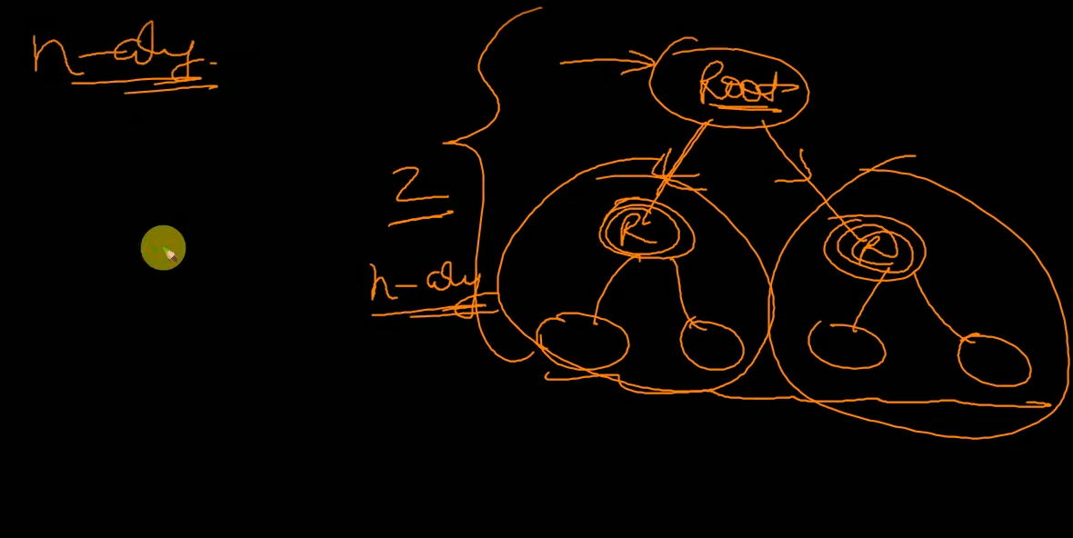

Trie dictionary structure:

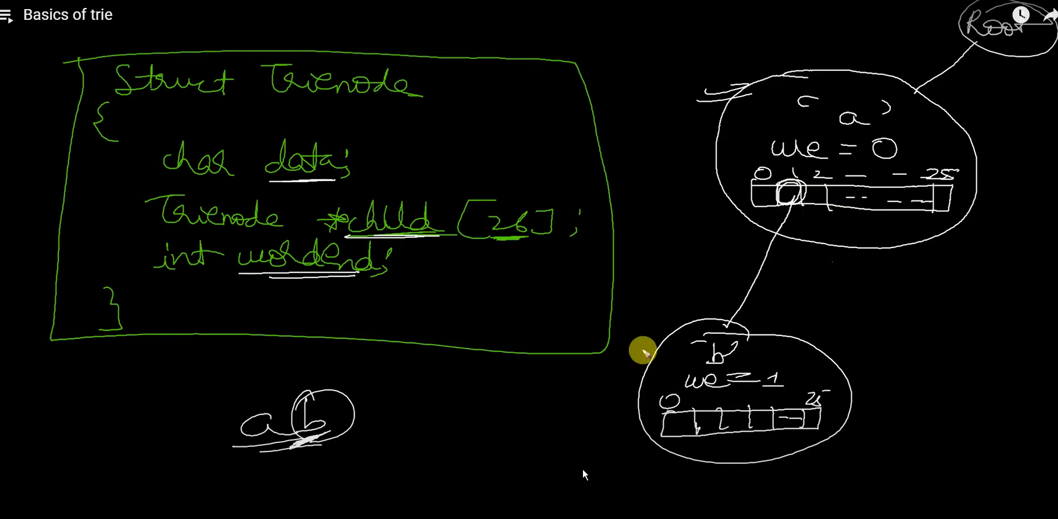

* Data => root data/char what the node will represents
* Counter => how many strings end with this root char as end char..
* Child pointers => pointer to represent next root char trie node’s location.

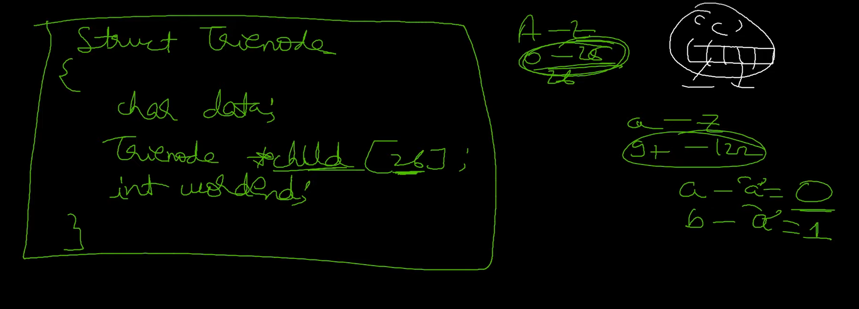

Child pointers is with 26chars and subtraction of any char with ‘a’ char will give its index for easy access of things..

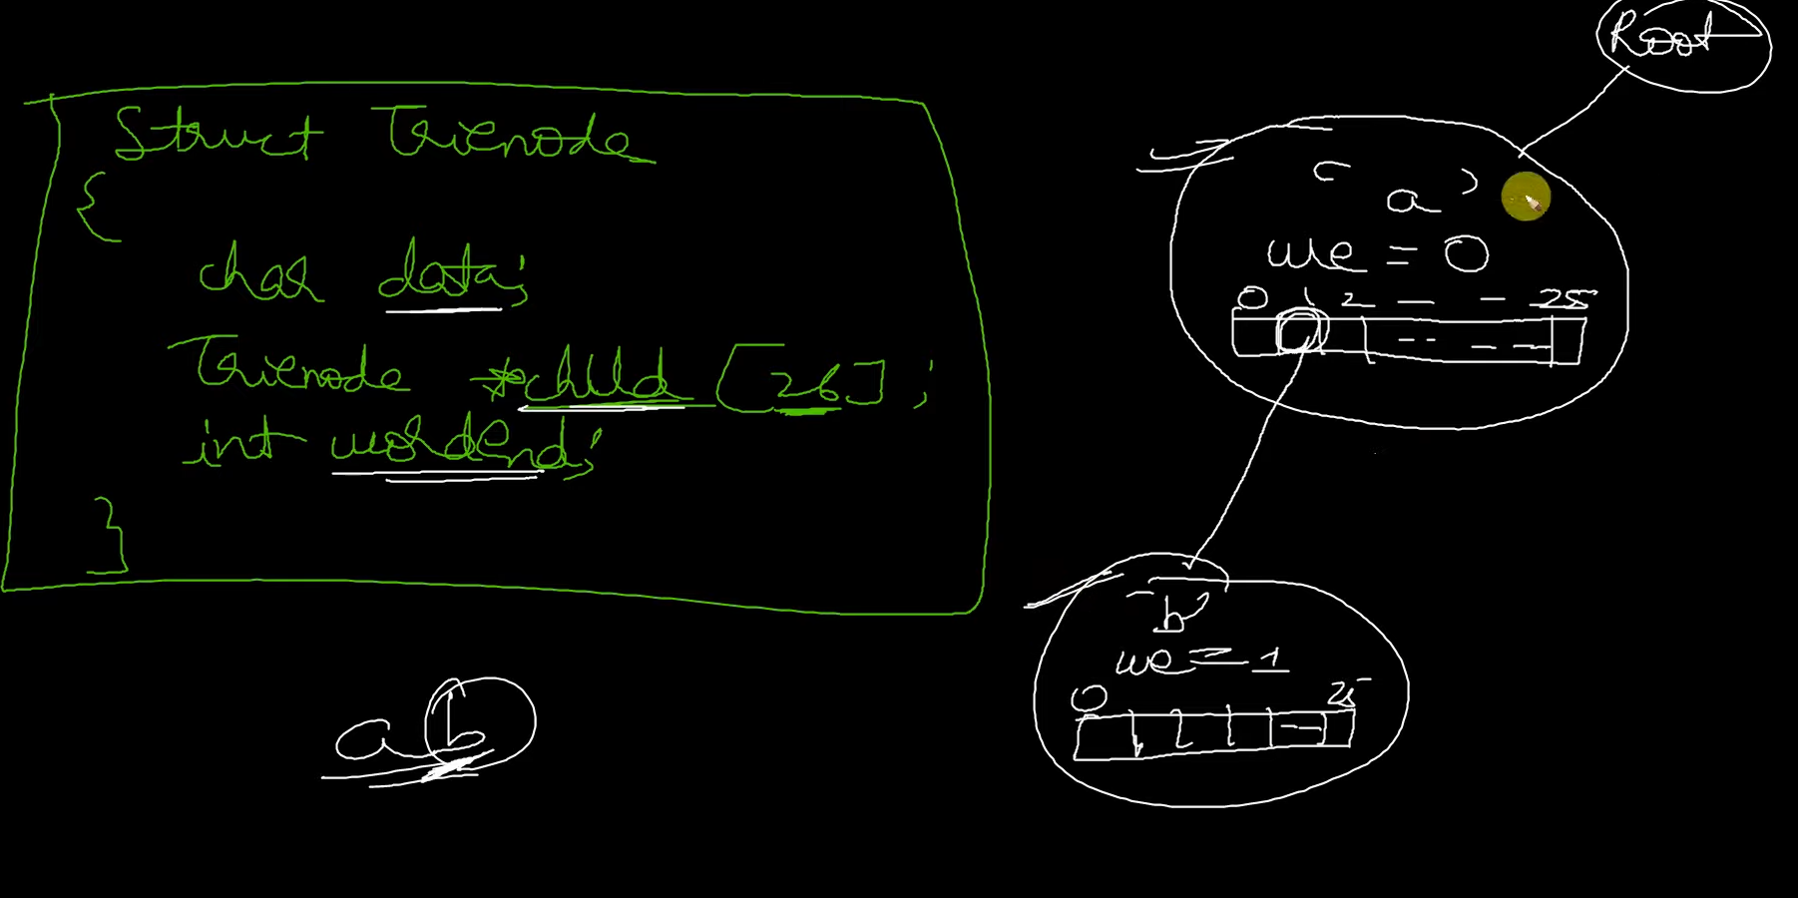

Root node – empty data represent empty string..

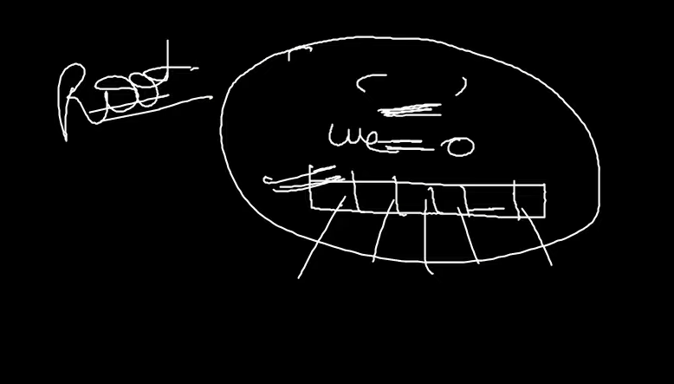

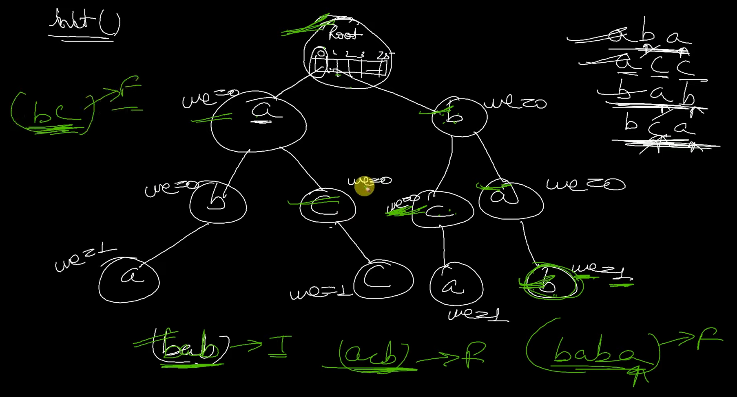

Create trie nodes for set of inputs… by which we defined trie dictionaly..  
then search for words, if no node found or no worked end char have word counter 0 , its not found, else found..

Benefits of trie:

* Best data structure for dictionary
* Insert, search, delete -> performant
* Search => done with O(n) => n – no.of chars in string
* Wide application in finding prefix in string
* Well structured and ordered data structure…

Trie application and operations:

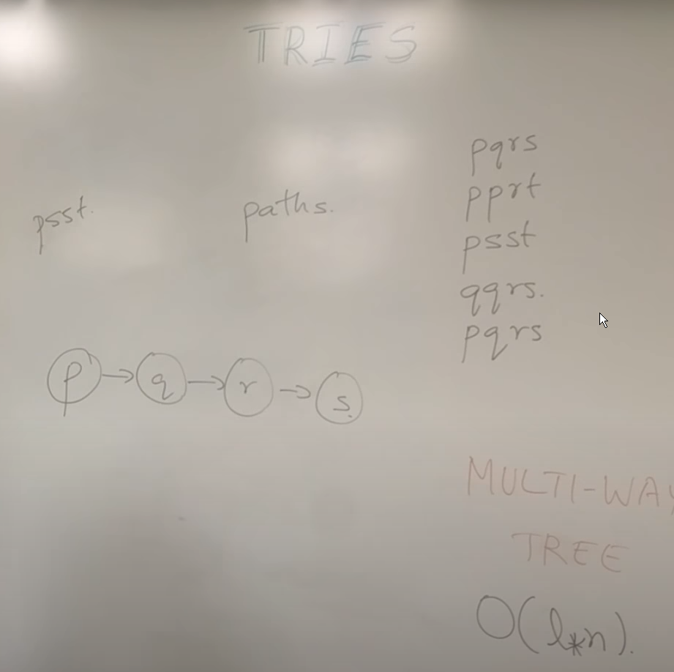

Basically used for matching char in string..

if you want to find all frequency of string..

so its complexity is length_of_string * possible_chars i.e O (l*n)

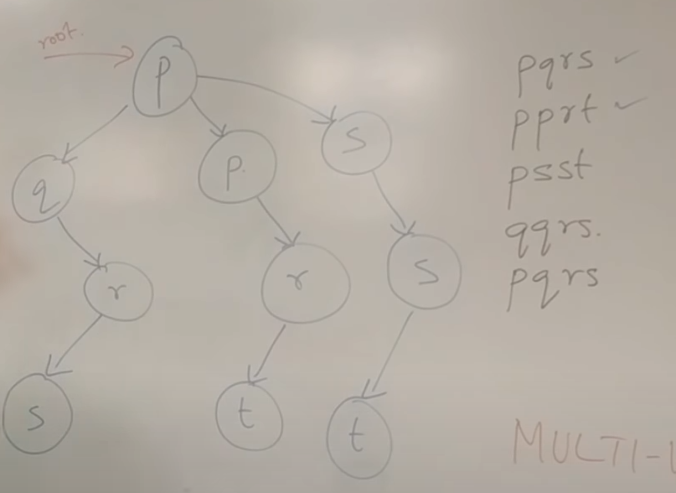

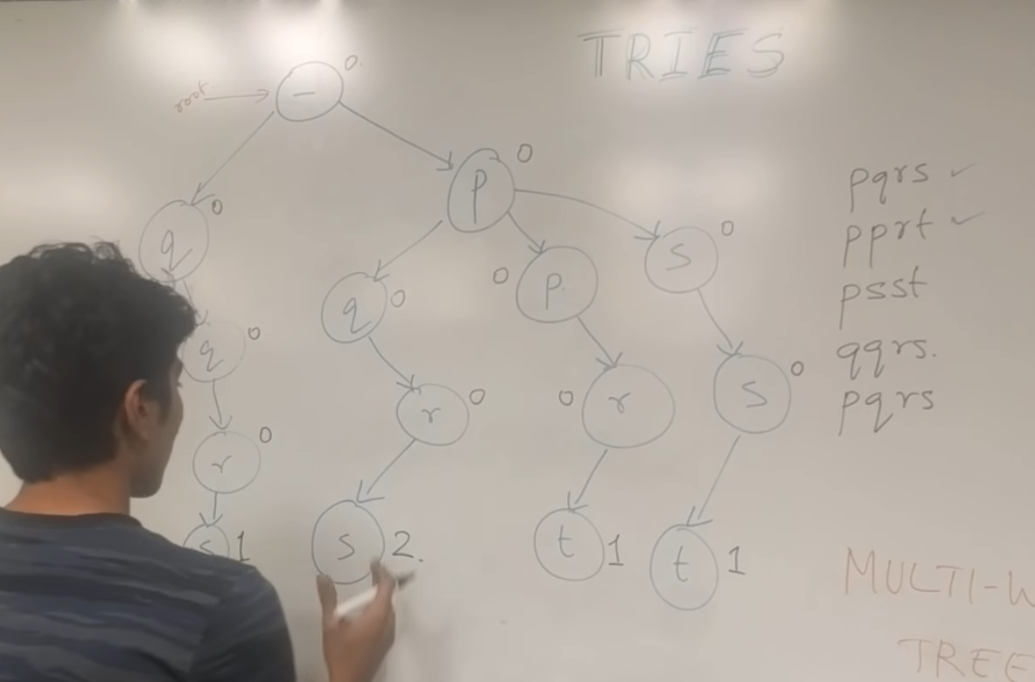

We can have start null pointer and each unique char into subsequent linking pointer and make the end char pointer value as counter… by which we can have occurrence of a string.

Insertion => if already exist, use them or add new node for that char

Search => whether all nodes in path are available in sequential with required end counter value

Deletion => make the end char counter to -1 and check whether all path have value in end counter, if not start deleting nodes.

Deletion explanation:

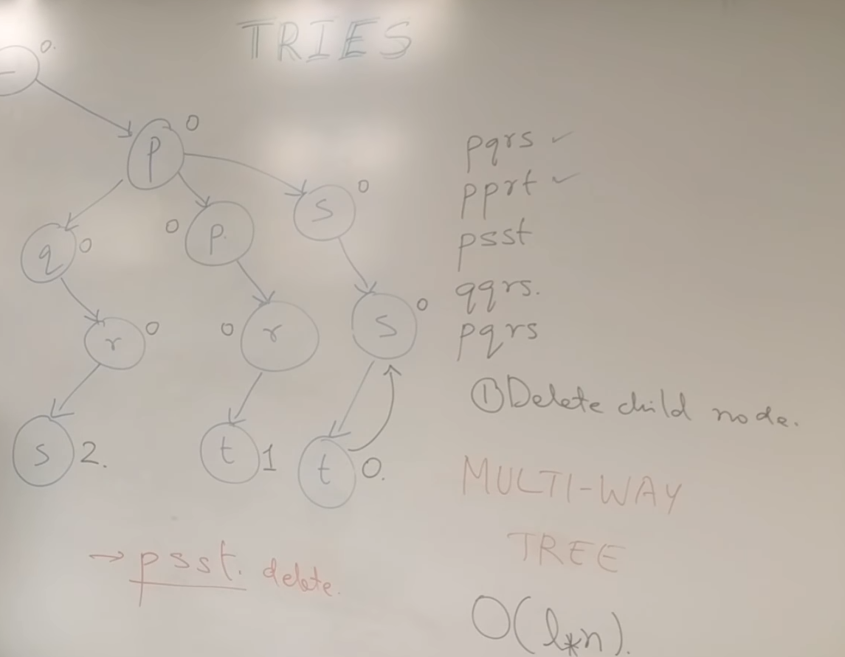

Reduce counter and delete nodes with no child parent or 0 counter leaf nodes…

In this case, delete psst,

Make t counter -1,

0 counter t char node will be deleted,

s,s parents will be deleted…

for updation => first delete old string repr and then insert new string repr by which updation will be done.

Trie operations in detail:

Insertion:

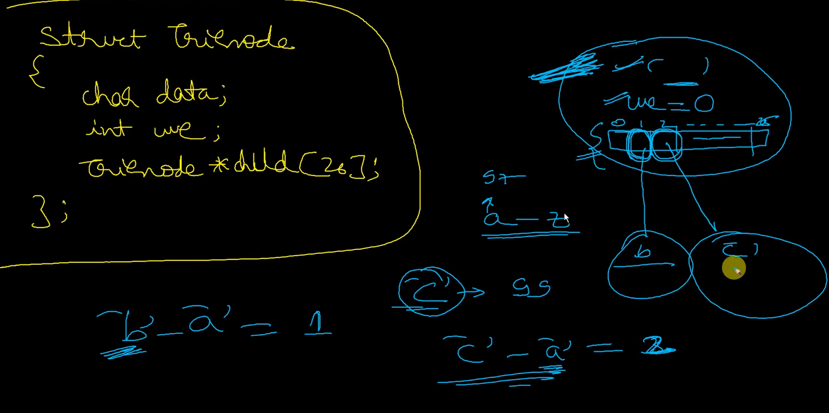

Each new char will get new trie node, and it it pointed to the previous node’s pointer child.. which is stored in perfect indices .. ( based on subtraction of ‘a‘ char ) …

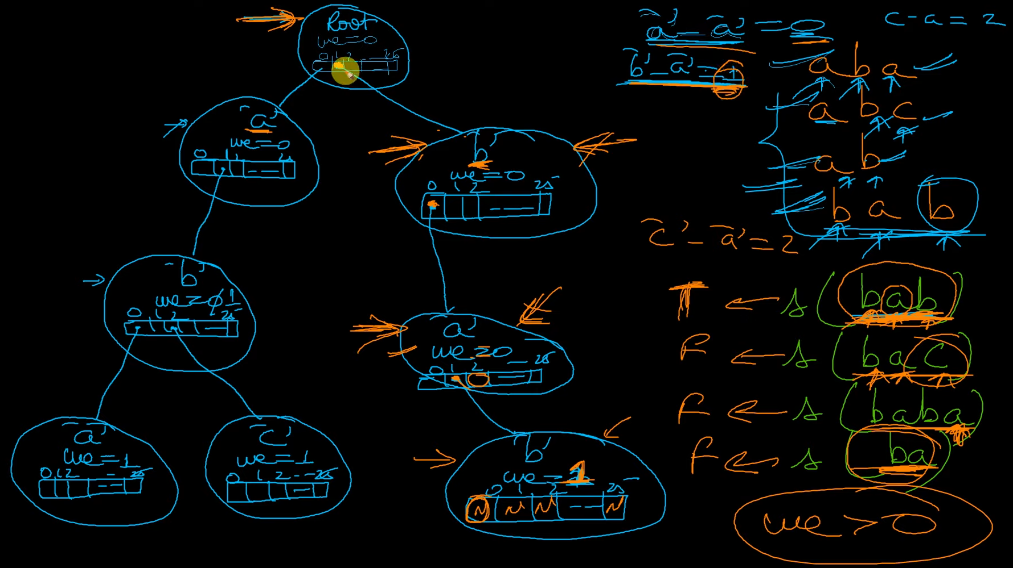

Deletion:

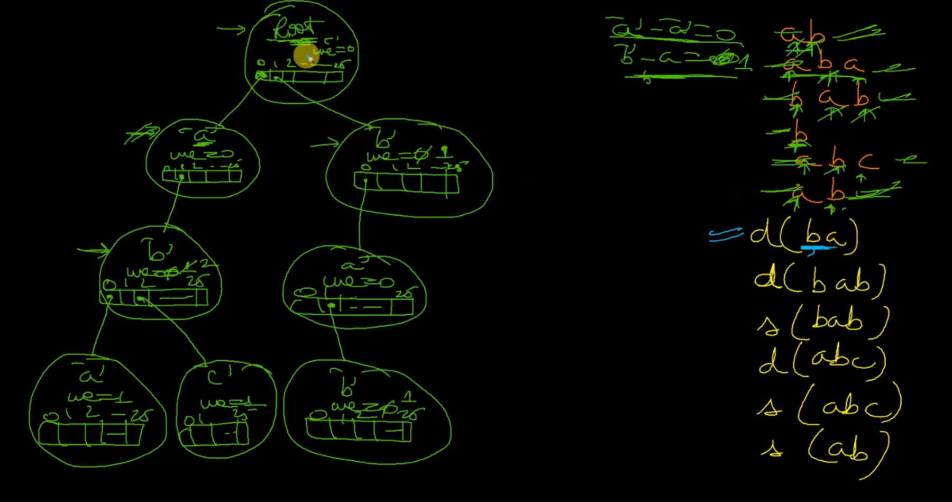

While deletion, will check word end.. if not zero, make it -1 and remove leaf with 0 word end and remove parent with no children.

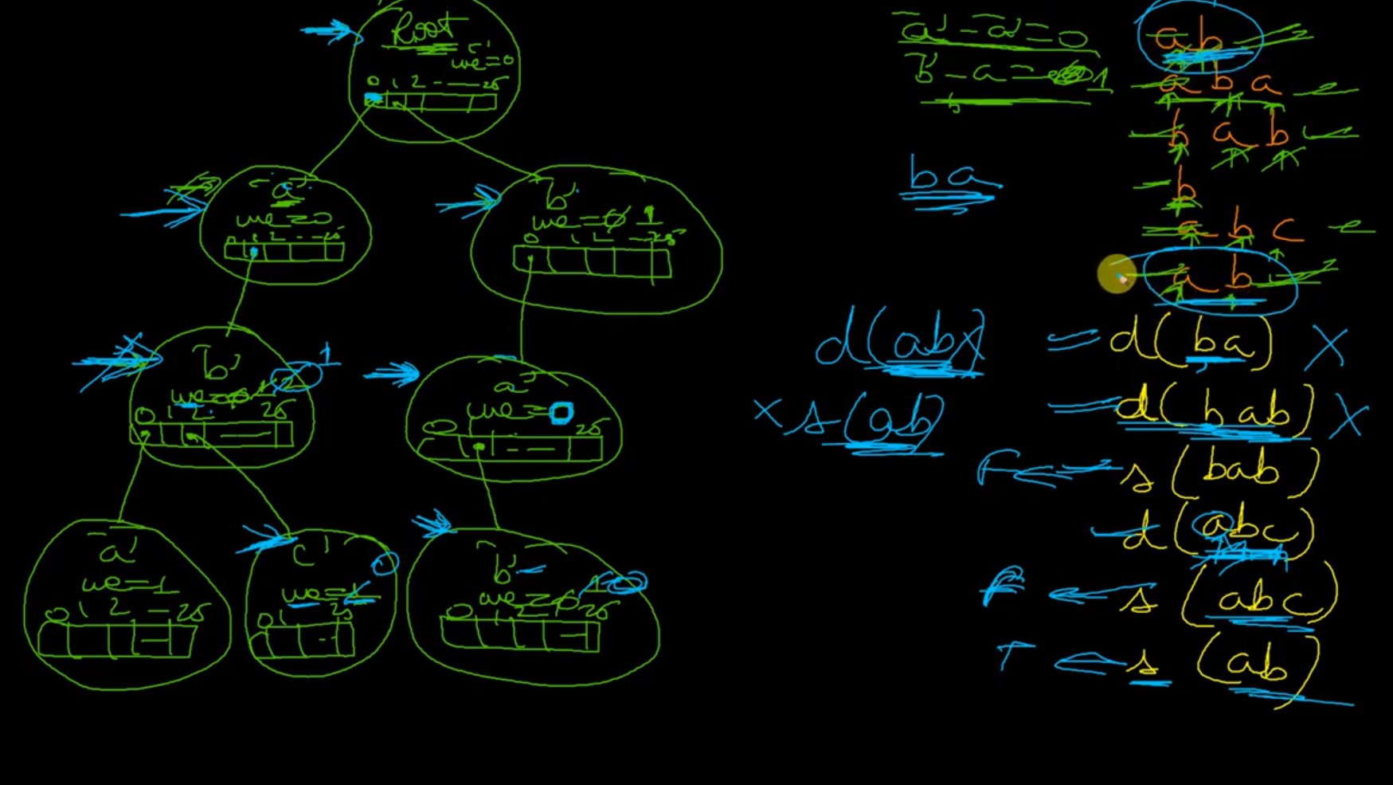

Clearing of empty nodes can be done at last after all deletion completes and traversing to all nodes.

Count num of strings of prefix:

Instead of word count, we can have prefix count in order to track the repeatation of substrings..

While creation of node itself, put start prefix count with 1 and increment it whenever you encounter the same node..

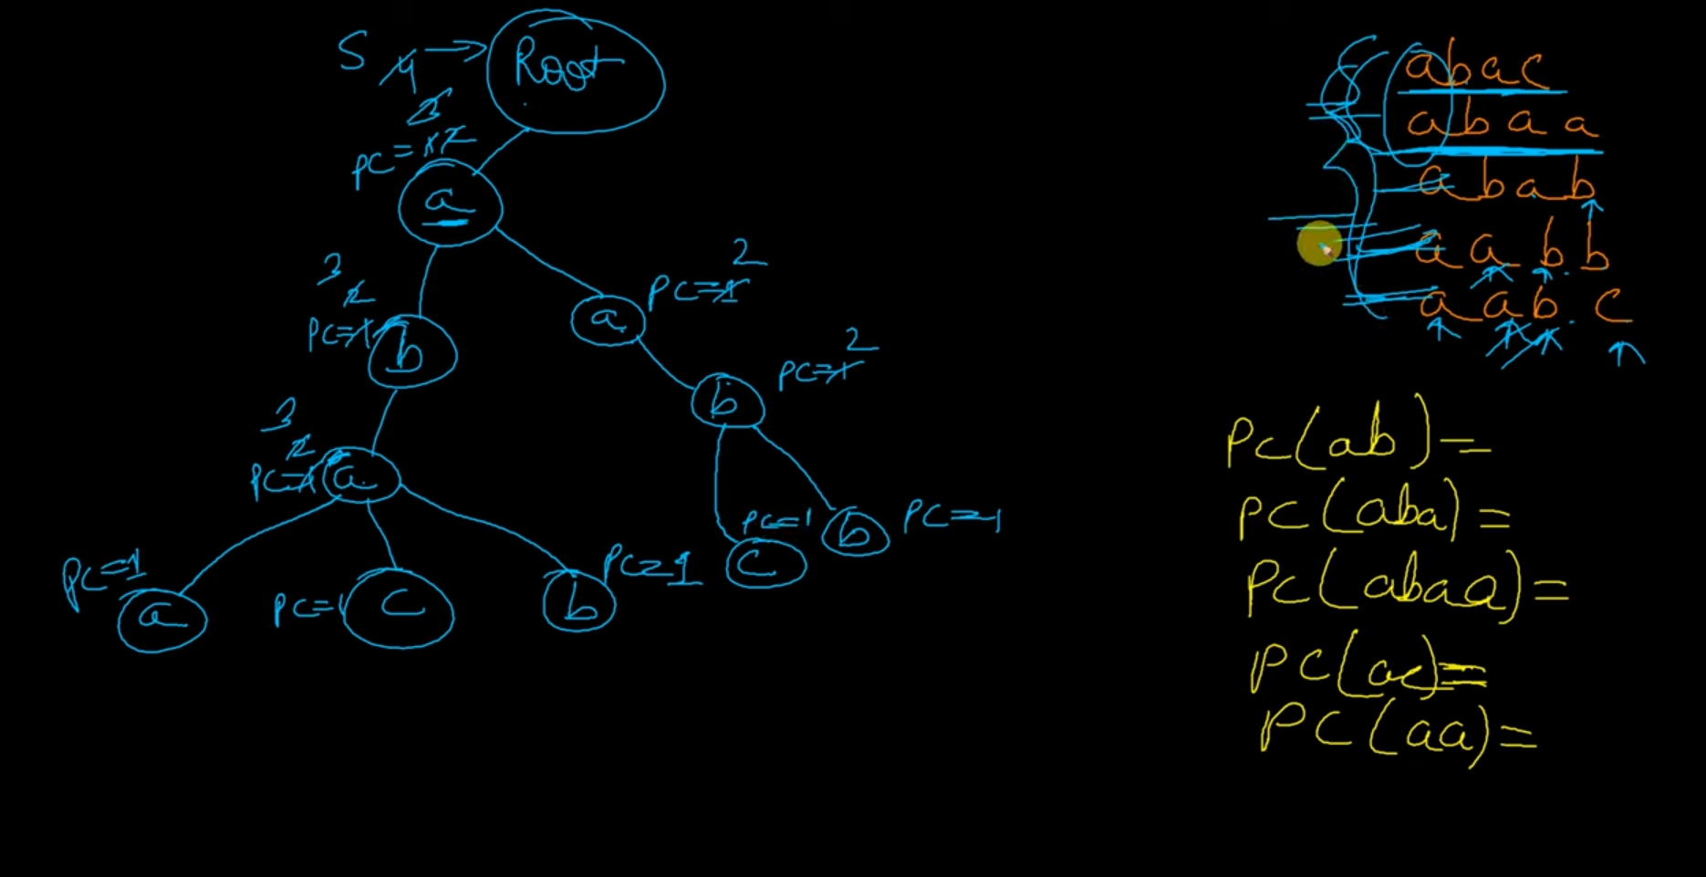

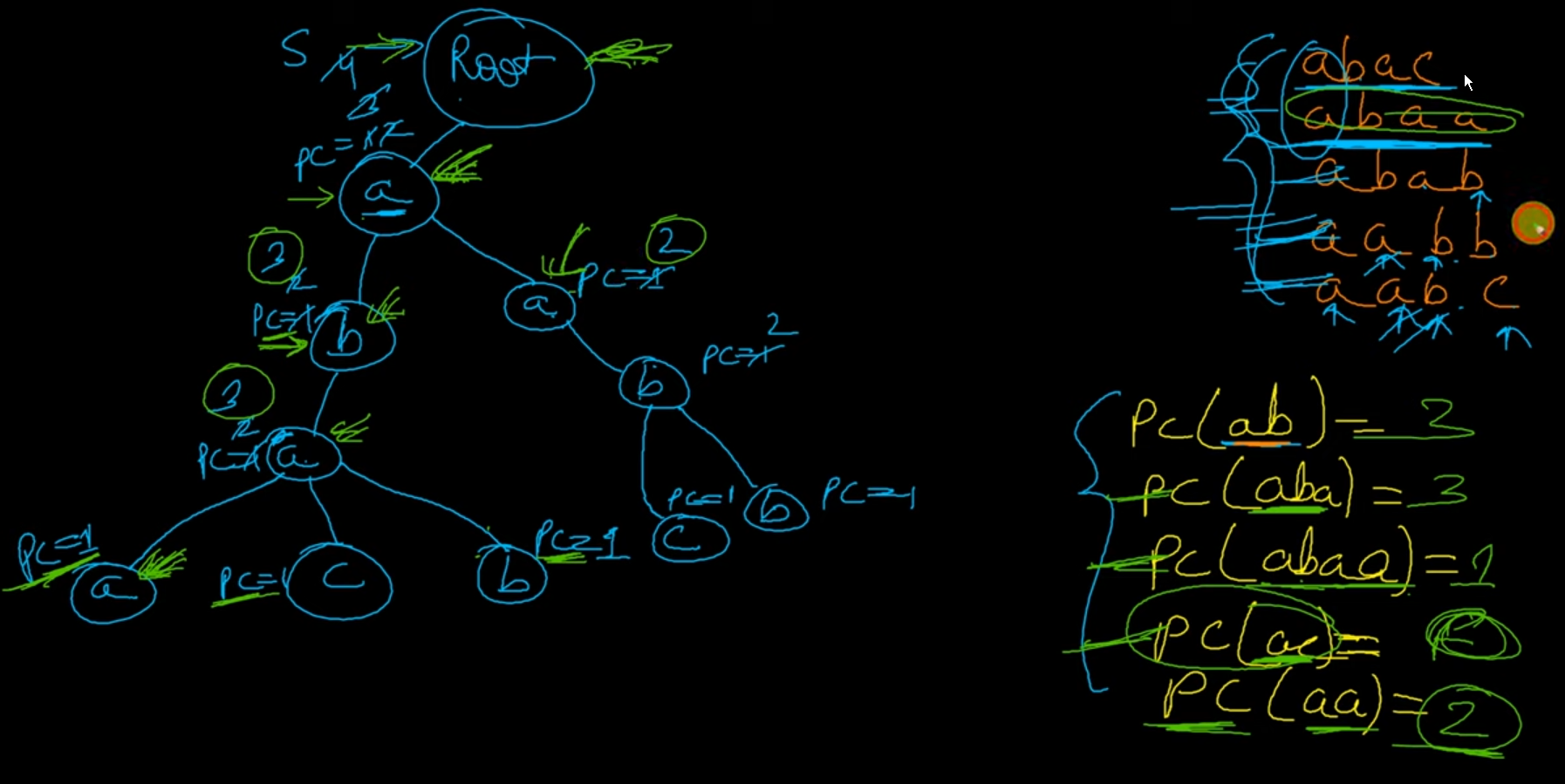

// CODE TO Count_Number_Of_Strings_With_Given_Prefix

// Assumption: All characters are in lowercase

#include <iostream>

using namespace std;

//#define NULL 0

struct Trienode {

  char data;

  int wc; // wc:word_count

  Trienode *child[26];

};

Trienode nodepool[100000]; // Pool of 100K Trienodes

int poolcount;             // Always points to next free Trienode

Trienode *root;            // Root of Trie

void init() // Initializer function

{

  poolcount = 0;

  root = &nodepool[poolcount++];

  root->data = '/';

  for (int i = 0; i < 26; ++i)

    root->child[i] = NULL;

}

Trienode *getNode(char c) {

  Trienode *newnode = &nodepool[poolcount++];

  newnode->data = c;

  for (int i = 0; i < 26; ++i)

    newnode->child[i] = NULL;

  newnode->wc = 0;

  return newnode;

}

void insert(char *s) {

  Trienode *curr = root;

  int index;

  for (int i = 0; s[i] != '\0'; ++i) {

    index = s[i] - 'a';

    if (curr->child[index] == NULL)

      curr->child[index] = getNode(s[i]);

    curr->child[index]->wc += 1;

    curr = curr->child[index];

  }

}

bool search(char *s) {

  Trienode *curr = root;

  int index;

  for (int i = 0; s[i] != '\0'; ++i) {

    index = s[i] - 'a';

    if (curr->child[index] == NULL || curr->child[index]->wc == 0)

      return false;

    curr = curr->child[index];

  }

  return true;

}

bool Triedelete(char *s) {

  if (search(s)) {

    Trienode *curr = root;

    int index;

    for (int i = 0; s[i] != '\0'; ++i) {

      index = s[i] - 'a';

      curr->child[index]->wc -= 1;

      curr = curr->child[index];

    }

    return true;

  }

  return false;

}

int countPrefix(string s) {

  Trienode *curr = root;

  int index;

  for (int i = 0; s[i] != '\0'; ++i) {

    index = s[i] - 'a';

    if (curr->child[index] == NULL || curr->child[index]->wc == 0)

      return 0; // No string with given prefix is present

    curr = curr->child[index];

  }

  return curr->wc;

}

int main() {

  init();

  char a[5] = {'a', 'r', 'm', 'y'};

  char b[5] = {'a', 'r', 'm'};

  char c[5] = {'a', 'r', 'm', 's'};

  char d[5] = {'a', 'r', 'y'};

  char e[5] = {'a', 'm', 'y'};

  char f[5] = {'a', 'p', 'i'};

  char x[5] = {'a', 'p', 'p'};

  insert(a);

  insert(b);

  insert(c);

  insert(d);

  insert(e);

  insert(f);

  printf("inserted strings are %s, %s, %s, %s, %s, %s \n", a, b, c, d, e, f);

  printf("search for %b ", b);

  cout << search(b) << "\n";

  printf("No of strings with %s prefix = %d\n", "a", countPrefix("a"));

  printf("No of strings with %s prefix = %d\n", "ar", countPrefix("ar"));

  printf("No of strings with %s prefix = %d\n", "arm", countPrefix("arm"));

  printf("No of strings with %s prefix = %d\n", "army", countPrefix("army"));

  printf("No of strings with %s prefix = %d\n", "armi", countPrefix("armi"));

  printf("No of strings with %s prefix = %d\n", "ary", countPrefix("ary"));

  printf("Deleted string %s status => %s\n", a,

         Triedelete(a) ? "deleted" : "error");

  printf("Deleted string %s status => %s\n", d,

         Triedelete(d) ? "deleted" : "error");

  printf("Deleted string %s status => %s\n", x,

         Triedelete(x) ? "deleted" : "error");

  printf("No of strings with %s prefix = %d\n", "a", countPrefix("a"));

  printf("No of strings with %s prefix = %d\n", "ar", countPrefix("ar"));

  printf("No of strings with %s prefix = %d\n", "arm", countPrefix("arm"));

  printf("No of strings with %s prefix = %d\n", "army", countPrefix("army"));

  printf("No of strings with %s prefix = %d\n", "armi", countPrefix("armi"));

  printf("No of strings with %s prefix = %d\n", "ary", countPrefix("ary"));

  /* output

      inserted strings are army, arm, arms, ary, amy, api

      search for %b 1

      No of strings with a prefix = 6

      No of strings with ar prefix = 4

      No of strings with arm prefix = 3

      No of strings with army prefix = 1

      No of strings with armi prefix = 0

      No of strings with ary prefix = 1

      Deleted string army status => deleted

      Deleted string ary status => deleted

      Deleted string app status => error

      No of strings with a prefix = 4

      No of strings with ar prefix = 2

      No of strings with arm prefix = 2

      No of strings with army prefix = 0

      No of strings with armi prefix = 0

      No of strings with ary prefix = 0

    */

  return 0;

}

Auto complete using trie:

Insert given strings

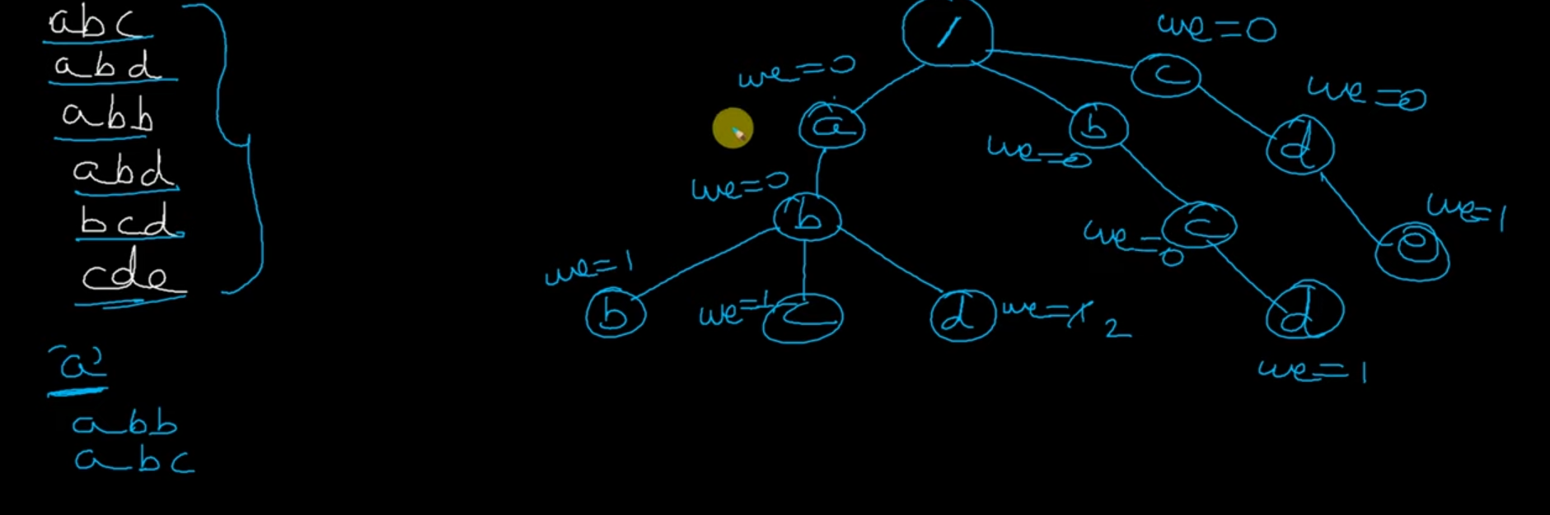

Top 1 suggestion

Use pre order traversal and consider showing them in alphabetical order..

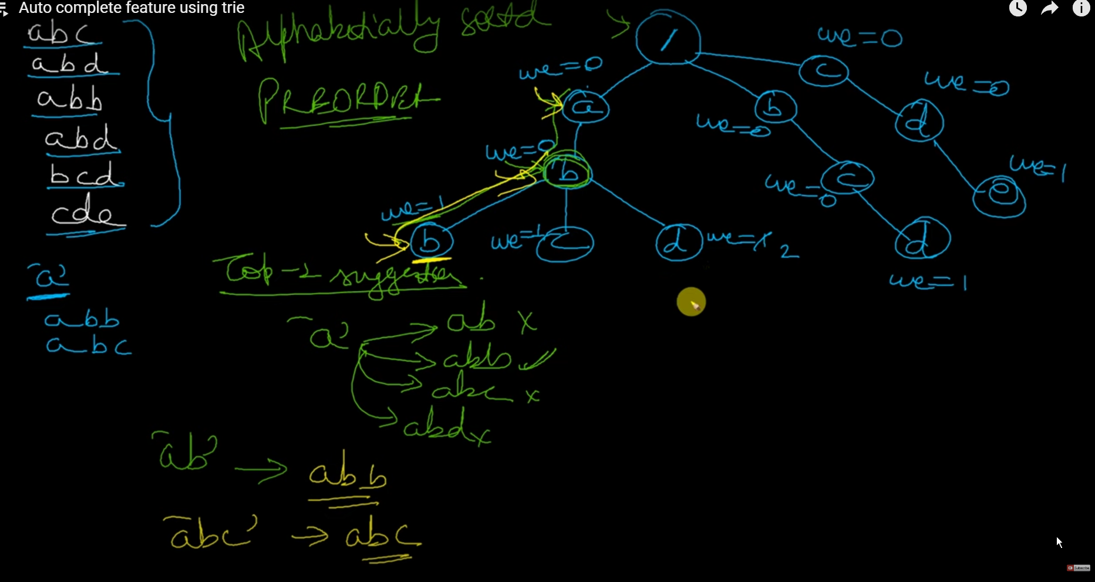

Top 3 suggestion

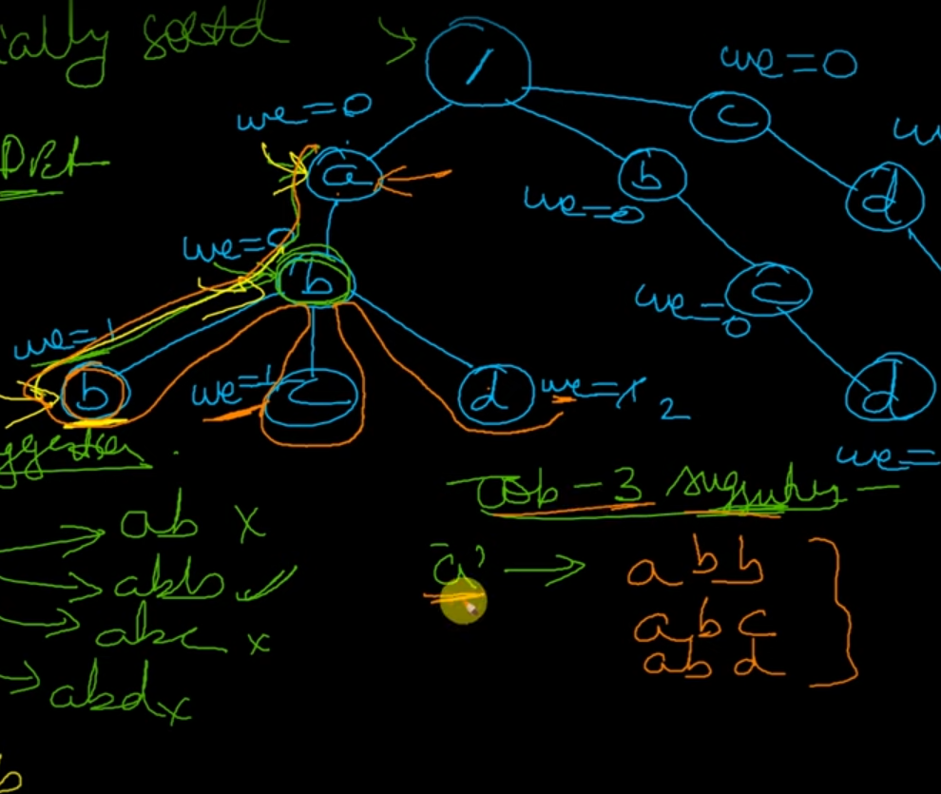

Insear ab , and find top 3 suggestions..

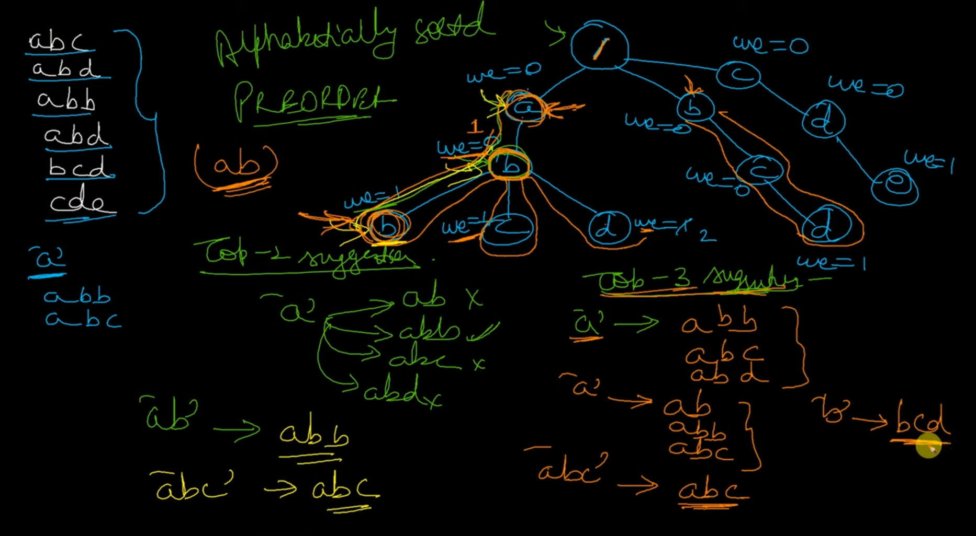

Complexity analysis:

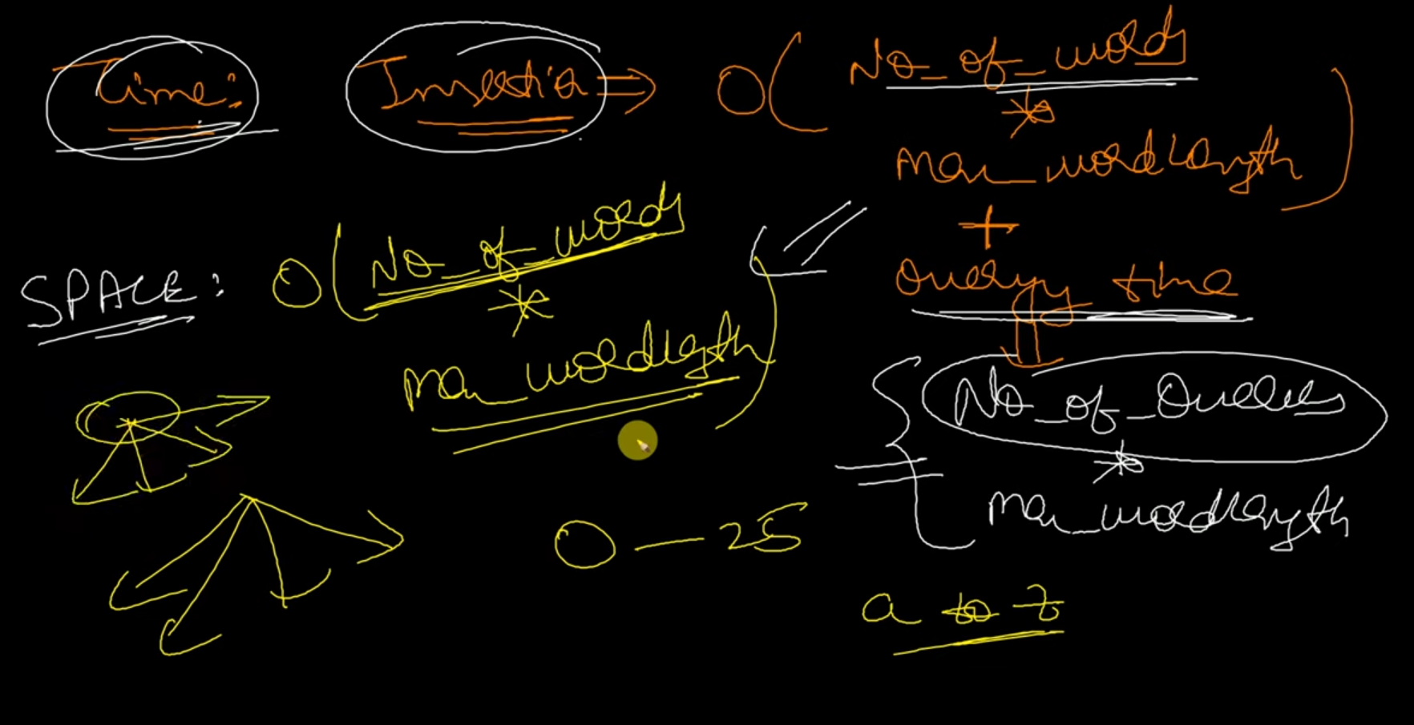

Space => O (no.of.words * max_word_leng)

Insertion Time => O (no.of.words * max_word_leng) + query time i.e (no.of.queries * max_leng)

Referred {

Gaurav Sen

<https://youtu.be/YG6iX28hmd0>

}

Referring {

Tech does

<https://youtube.com/playlist?list=PLEJXowNB4kPyi859E6qGUs7jlpQehJndl>

}